Lecture 3

- Devloping a real scheduling algorithm: multi level feadback queues

in mlfq
→ we have multible queues with different priorities
→ if priority(A) > priority(B) then A is running while B is not
→ if priority(A) = priority(B) then roundrobin between them
→ we always starts at the hights priority
→ if a process spend Tx in the queue it is moved down one level
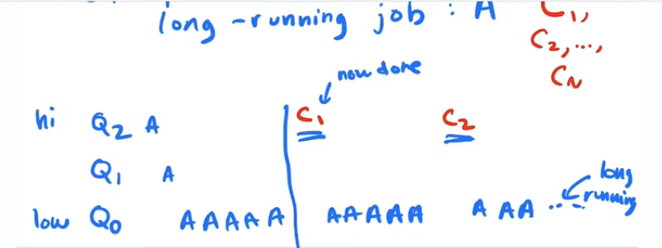
long-running jobs may starve → so as time goes by we will increase priority of the lower priority jobs

